**Day-3 session-3(14/08/2024)**

**Step-1:** connecting to the instances, usage of uname command

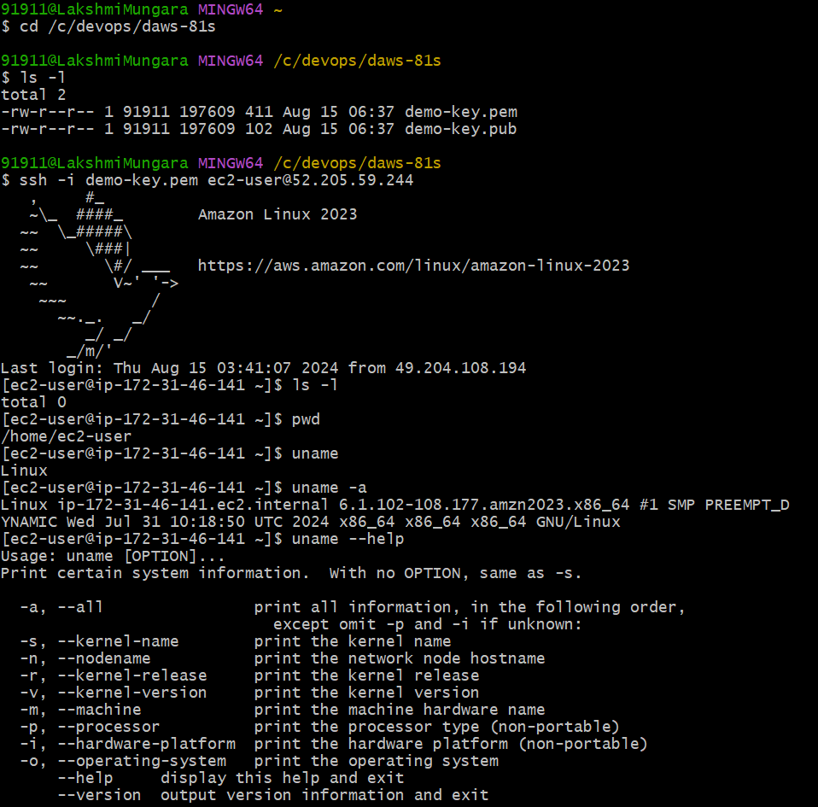

**Step-2:** cp command 🡪 cp <source-file> <destination-file>

and grep command usage 🡪 grep <word> <file-name>

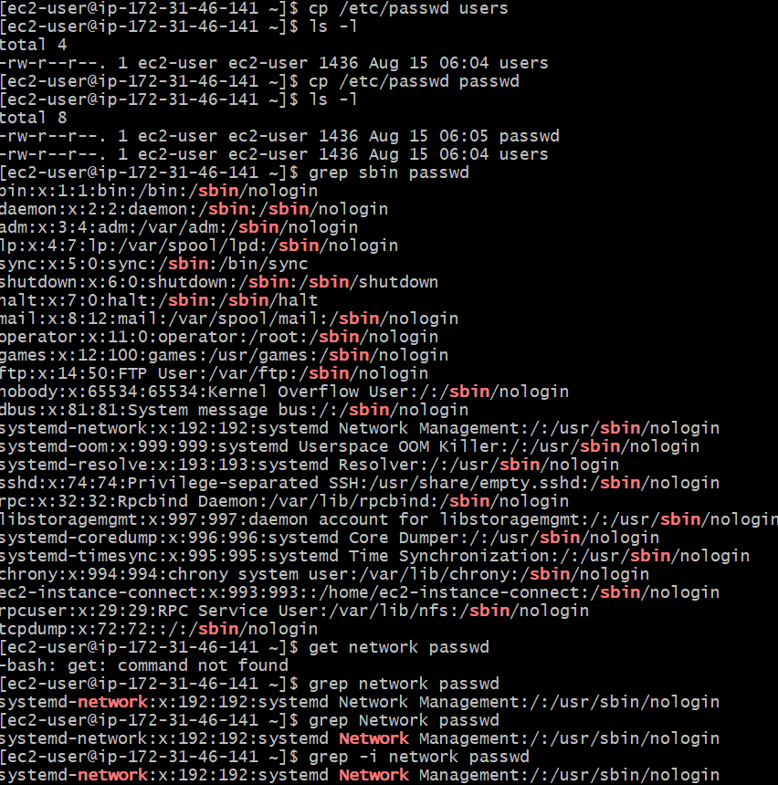

**Step-3**: wget<URL> and curl<URL>

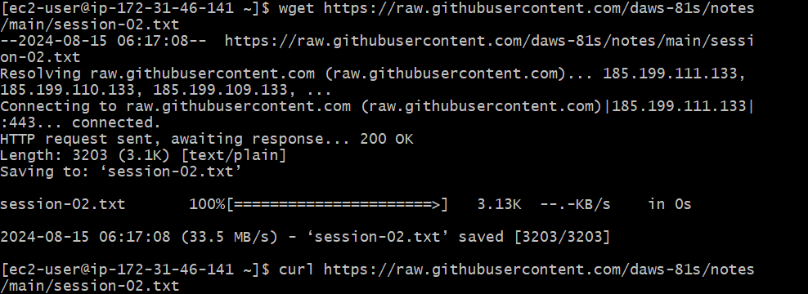

**Step-4:** cut and awk commands

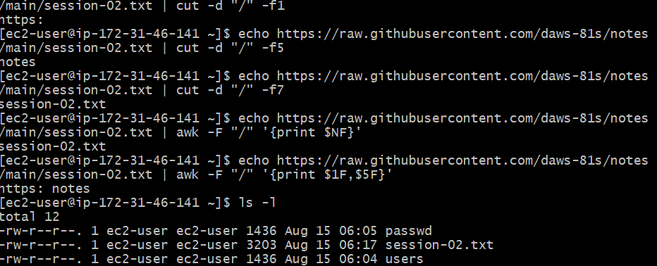

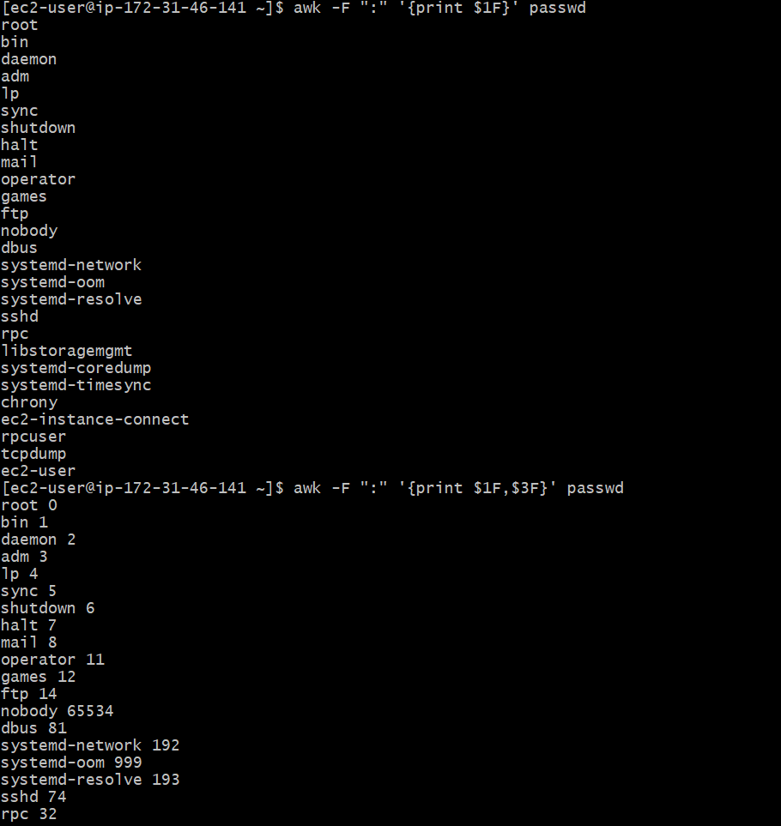

**Step-5:**  head and tail commands

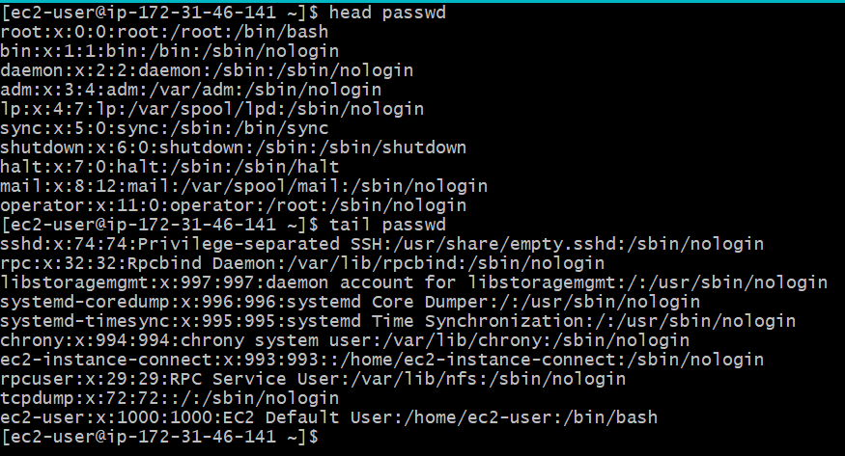

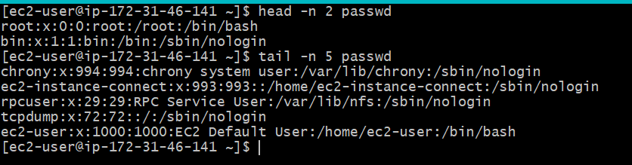

**Step-6:** word count

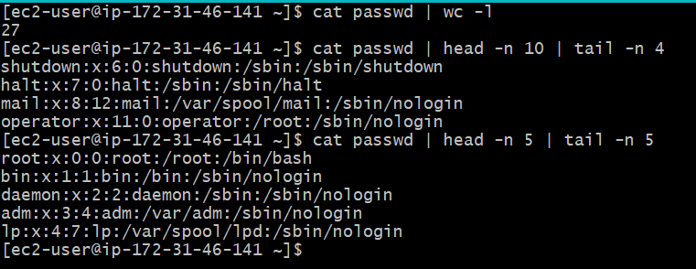

**Step-9**: enter vim <file-name>

Colon/command mode

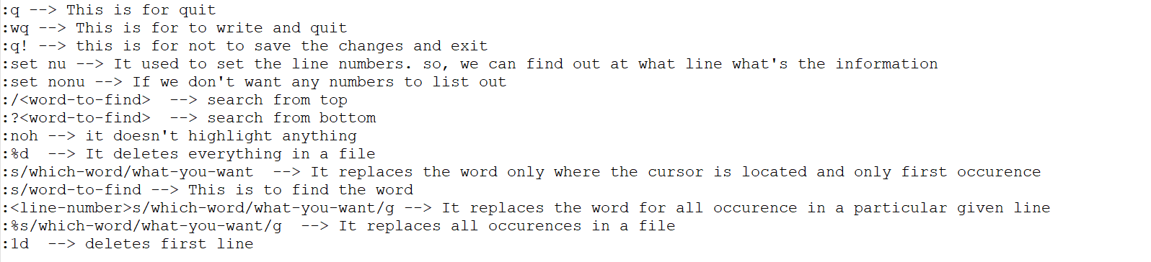

**Step-10**: Esc mode

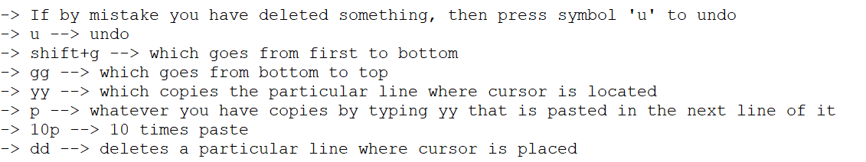

**Step-11**: Permissions(read, write and execute)

